THE UNIVERSITY OF AZAD JAMMU AND KASHMIR, MUZAFFARABAD



|  |  |
| --- | --- |
| COURSE TITLE | CALD |
| COURSE CODE | CS-1205 |
| ASSIGNMENT TITLE | Encoder & Decoder |
| STUDENT NAME | Tayyab Hanif Awan |
| STUDENT ROLL NUMBER | 2024-SE-11 |
| INSTRUCTOR NAME | Engr. Sidra Rafique |
| SUBMISSION DATE | 19th August, 2025 |
| LAB No. | 07 |

**Encoders & Decoders**

Encoders and decoders are fundamental digital logic circuits used in **data communication, processing, and control systems**.

* An **encoder** converts information from one form to another, typically from **2ⁿ input lines into n-bit coded output**.
* A **decoder** performs the reverse operation, converting **n-bit coded input into 2ⁿ unique output lines**.

Together, they enable efficient data representation, transmission, and interpretation in digital systems.

**1. Encoder**

An **encoder** is a combinational circuit that converts **active input signals into a binary code** on the output lines. It reduces multiple inputs into fewer outputs.

**General Function**

* Number of input lines = **2ⁿ**
* Number of output lines = **n**

**Example: 8-to-3 Encoder**

**Truth Table:**

| **D7 D6 D5 D4 D3 D2 D1 D0** |  |  |  | **C B A** |  |
| --- | --- | --- | --- | --- | --- |
|  |  |  |  |  |  |
| 0 0 0 0 0 0 0 **1** |  |  |  | 0 0 0 |  |
| 0 0 0 0 0 0 **1** 0 |  |  |  | 0 0 1 |  |
| 0 0 0 0 0 **1** 0 0 |  |  |  | 0 1 0 |  |
| 0 0 0 0 **1** 0 0 0 |  |  |  | 0 1 1 |  |
| 0 0 0 **1** 0 0 0 0 |  |  |  | 1 0 0 |  |
| 0 0 **1** 0 0 0 0 0 |  |  |  | 1 0 1 |  |
| 0 **1** 0 0 0 0 0 0 |  |  |  | 1 1 0 |  |
| **1** 0 0 0 0 0 0 0 |  |  |  | 1 1 1 |  |

**Output Expressions:**

C​ =D4​+D5​+D6​+D7​

B =D2​+D3​+D6​+D7​

A =D1​+D3​+D5​+D7​​

**Implementation:**

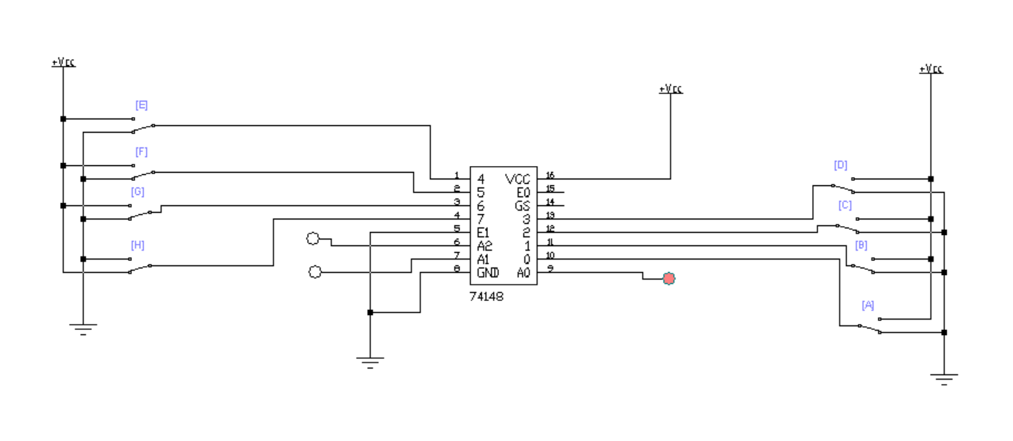

**2. Decoder**

A **decoder** is a combinational circuit that does the reverse of an encoder. It **translates coded binary inputs into a specific output line**, activating exactly one output for each input combination.

**General Function**

* Number of input lines = **n**
* Number of output lines = **2ⁿ**

**Example: 3-to-8 Decoder**

**Truth Table:**

| **C** | **B** |  |  | **A** | **Y7 Y6 Y5 Y4 Y3 Y2 Y1 Y0** |
| --- | --- | --- | --- | --- | --- |
| 0 | 0 |  |  | 0 | 0 0 0 0 0 0 0 **1** |
| 0 | 0 |  |  | 1 | 0 0 0 0 0 0 **1** 0 |
| 0 | 1 |  |  | 0 | 0 0 0 0 0 **1** 0 0 |
| 0 | 1 |  |  | 1 | 0 0 0 0 **1** 0 0 0 |
| 1 | 0 |  |  | 0 | 0 0 0 **1** 0 0 0 0 |
| 1 | 0 |  |  | 1 | 0 0 **1** 0 0 0 0 0 |
| 1 | 1 |  |  | 0 | 0 **1** 0 0 0 0 0 0 |
| 1 | 1 |  |  | 1 | **1** 0 0 0 0 0 0 0 |

**Output Expressions:**

Y0​​​=EB’A’

Y1=EB’A

Y2=EBA’

Y3=EBA​

**Implementation:**

